**Billy Ray Cyrus Net Worth ( American Actor, Singer, and Songwriter )**

[**Billy Ray Cyrus Net Worth**](https://thenetworthstars.com/billy-ray-cyrus-net-worth/) Billy Ray Cyrus is an American professional singer, songwriter, and actor. Billy Cyrus was born in Flatwoods, Kentucky, Unites States on August 25, 1961. Billy is known for his number one single “Achy Breaky Heart” and has released 12 studio albums and 44 singles since 1992 so far. Billy Ray Cyrus “Achy Breaky Heart” is the only single in the history to achieve the first ever triple platinum status in Australia. The single was translated into more than 100 languages and was the best-selling single in the same country. [Billy Ray Cyrus Net Worth](https://thenetworthstars.com/billy-ray-cyrus-net-worth/) is around $20 million. The line dance catapulted into the mainstream becomes a worldwide craze. Cyrus was the only singer in the history who has scored a total of eight top-ten singles on the Billboard Country Songs. Billy Cyrus debut album was the most successful album for him to date which has certified 9 Multi-Platinum in the United States and is the longest running time spent (17 weeks) debut album on the Billboard 200 chart. It is the only album in the SoundScan era to be on top of the chart for 17 most consecutive weeks and is also the top-ranking debut album by a male artist in the United States.

[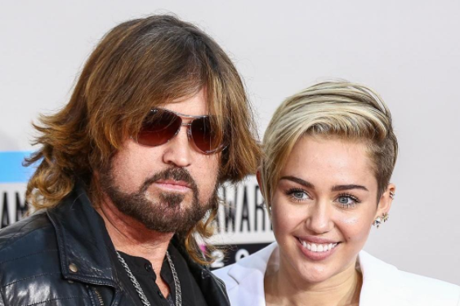](https://thenetworthstars.com/billy-ray-cyrus-net-worth/)

**How Billy Ray Spent his Early Life?**

William Ray Cyrus was born in Flatwoods, Kentucky from Ron Cyrus and Ruth Ann Casto. Billy Ray Cyrus has fond of music from his childhood and started singing from a very young age of 4 years. Billy was so lucky that he is surrounded by Bluegrass and gospel music artists within his family due to which Billy didn’t face many problems to pursue his music career. Billy attended Georgetown College on a baseball scholarship before changing his mind to music and acting. After attending Neil Diamond concert, Billy realized that he can become a singer too and was thus dropped out of school due to his passion for music and he set himself a target to start a career. Before signing a record deal “Mercury Nashville Records”, Billy played in a band called “Sly Dog”. [**Billy Ray Cyrus Net Worth**](https://thenetworthstars.com/billy-ray-cyrus-net-worth/) is around $20 million.

**Billy Ray Cyrus Wife and Children**

Billy Ray Cyrus was married to Cindy Smith whom he once co-wrote the songs which include “Wher’m I Gonna Live” and “Some Gave All”. Billy was has released his debut album “Some Gave All” and included both of the singles in his album. The couple was later divorced in 1993 and Billy Ray married to “Leticia Tish Cyrus”. Together they have 3 children including “Miley Cyrus”, Braison Chance and Noah Cyrus. The family lived on a farm outside Nashville, Tennessee.

[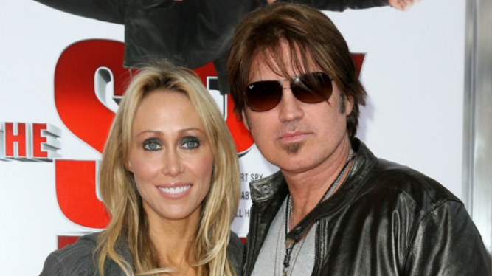](https://thenetworthstars.com/billy-ray-cyrus-net-worth/)

**How much is Billy Ray Cyrus Worth?**

[**Billy Ray Cyrus Net Worth**](https://thenetworthstars.com/billy-ray-cyrus-net-worth/) is around $20 million. Billy earned all this money from his albums and after the success of his album, his second album “It Won’t Be the Last” containing only four singles, debuted at number 1 on the country chart and #3 on Billboard 200 chart in the United States.

|  |  |
| --- | --- |
| Year | Net Worth |
| 2012 | $10 million |
| 2013 | $12 million |
| 2014 | $13 million |
| 2015 | $15 million |
| 2016 | $16 million |
| 2017 | $17 million |
| 2018 | $19 million |
| 2019 | $22 million |